NeonPingPong - Report
09-134262-015 · Faseeh Muhammad Babar

1. Introduction
For this assignment I made a two-player game called NeonPingPong in C++. Two players control a paddle each and hit a ball back and forth. When someone misses the ball, the other player gets a point. The first player to get 5 points wins and a game over screen comes up. After that, pressing R starts a new game.

The library I used: Raylib
Raylib is a free graphics library for C and C++. It lets us open a window, draw shapes and text, and check the keyboard without writing very hard code. I picked it because it is easy to learn and the function names are simple to understand. To use it I just added #include "raylib.h" at the top of my program.
These are the Raylib functions I used the most:
- InitWindow() and CloseWindow() to open and close the game window
- SetTargetFPS(60) to keep the game running at 60 frames per second
- BeginDrawing() and EndDrawing() to start and finish drawing each frame
- DrawRectangle(), DrawRectangleLinesEx() and DrawCircle() to draw shapes
- DrawText() and TextFormat() to show the scores and messages
- IsKeyDown() and IsKeyPressed() to read the keyboard
- GetRandomValue() to make the ball go in a random direction

2. Graphical Elements
The whole game is made of simple shapes and text. I used a dark blue background with bright "neon" colours (blue, red, yellow and white) so it looks like a cyberpunk-style arcade game. The window is 1000 x 650 pixels.
Element | How it was drawn | Colour
Background | ClearBackground() | Dark navy
Border | DrawRectangleLinesEx() around the screen | Neon blue
Centre line | Many small rectangles drawn in a loop | Faded blue
Player 1 paddle (left) | DrawRectangle(), 16 x 110 pixels | Neon blue
Player 2 paddle (right) | DrawRectangle(), 16 x 110 pixels | Neon red
Ball | DrawCircle() with radius 10 | Neon yellow
Glow effect | A slightly bigger, see-through rectangle or circle behind each object | Faded version of the same colour
Scores | DrawText() at the top | Blue and red
Title and controls | DrawText() | White
Game over box | A filled rectangle with a border, plus winner text | Dark box, coloured text
The glow was an easy trick. I drew the same shape again, a little bigger and with Fade() to make it see-through, and then drew the normal shape on top. This made the paddles and the ball look like they are shining.
The game over screen only appears when the gameOver variable is true. It shows which player won and tells the players to press R to play again.

3. How I Used Loops, Conditions, Arrays and Functions

Loops
I used three loops in the program.
- while loop: The main game loop in main() keeps the game running until the player closes the window. Every time it runs, the game updates and draws one frame.
while (!WindowShouldClose())
{
// update the game and draw it
}
- for loop (paddle limits): In MovePaddles(), one loop checks both paddles so neither can go outside the screen.
for (int i = 0; i < 2; i++)
{
if (py[i] < 10) py[i] = 10;
if (py[i] > H - PH - 10) py[i] = H - PH - 10;
}
- for loop (centre line): In DrawGame(), a loop draws a small rectangle every 35 pixels going down the screen. This makes the dotted line in the middle, so I did not have to write the rectangle many times.

Conditions (if / else)
Conditions are used everywhere in the game:
- Checking which keys are pressed (W, S, UP, DOWN) to move the paddles
- Making the ball bounce when it touches the top or bottom of the screen
- Checking if the ball hits the left or right paddle
- Giving a point when the ball goes past the left or right side
- Setting gameOver to true when a player reaches 5 points
- Choosing which winner message to show, and choosing a random up or down direction for the ball

Arrays
Both players have similar information, so I stored it in arrays of size 2 instead of making two sets of variables. Index 0 is Player 1 and index 1 is Player 2.
int px[2] = {45, W - 61}; // paddle x positions
int py[2] = {270, 270}; // paddle y positions
int score[2] = {0, 0}; // scores
This helped a lot because I could use a loop to handle both paddles, and score[0] and score[1] are easy to remember.

Functions
I split the program into small functions so the code is easier to read and fix. Each function has one job:
Function | What it does
ResetBall() | Puts the ball back in the centre and gives it a new random speed and direction
ResetGame() | Sets scores to 0, puts paddles in the middle and starts a new game
MovePaddles() | Reads the keys and moves the paddles, and keeps them inside the screen
MoveBall() | Moves the ball, handles bouncing, paddle hits, scoring and the win check
DrawGame() | Draws everything on the screen
main() | Opens the window and runs the main game loop
I also used constants like W, H, PW, PH, R and WIN_SCORE for the window size, paddle size, ball radius and winning score. If I want to change the size of the paddle or the winning score later, I only have to change one line.

4. Screenshots of Output
Screenshot 1: Game Running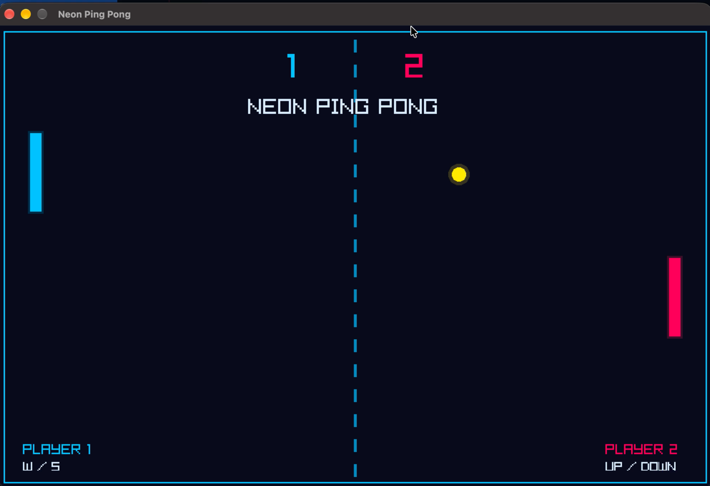

Screenshot 2: Game Over Screen 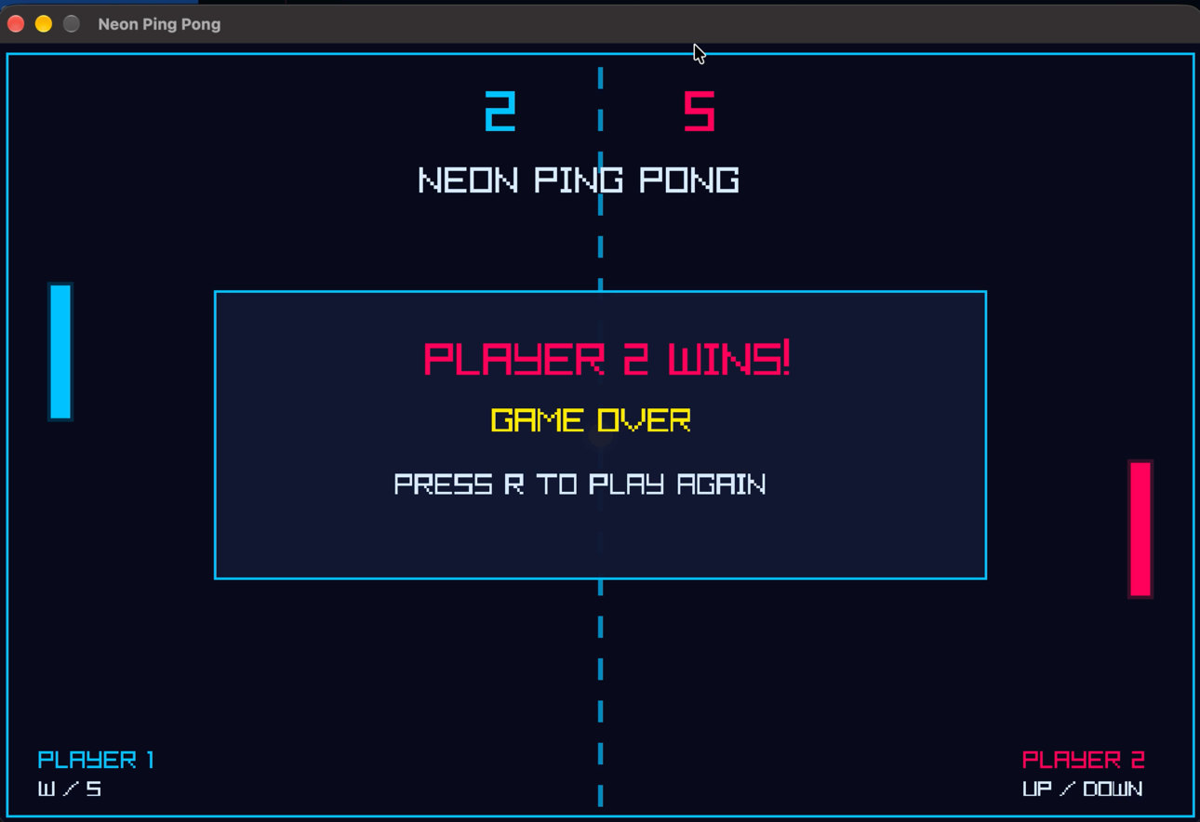

5. Final Output Summary
The final program is a working two player Neon Ping Pong game. Player 1 uses the W and S keys and Player 2 uses the UP and DOWN arrow keys. The ball bounces off the top and bottom walls and off the paddles. If it goes past a paddle, the other player scores. The first to 5 points wins, then the game over screen appears and R restarts everything.
Through this project I learned how to use a graphics library, and how loops, if conditions, arrays and functions work together in a real program. Splitting the code into functions made it much easier to find mistakes. The hardest part was the ball collision with the paddles, because there are many conditions to check at once. In the future I would like to add sound, a one player mode against the computer, and make the ball speed up during a rally.

